Parallel Projection
# Source: AI Source: Provided by: [Data Path: Persons Table -> ID Column: 1, Name_En Column: Motasem Essam] -> From: [ChatGPT] on [7/25/2026]
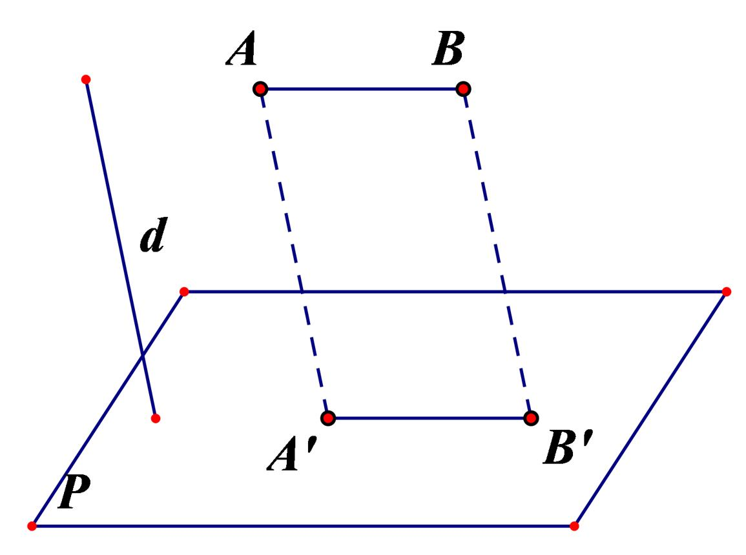
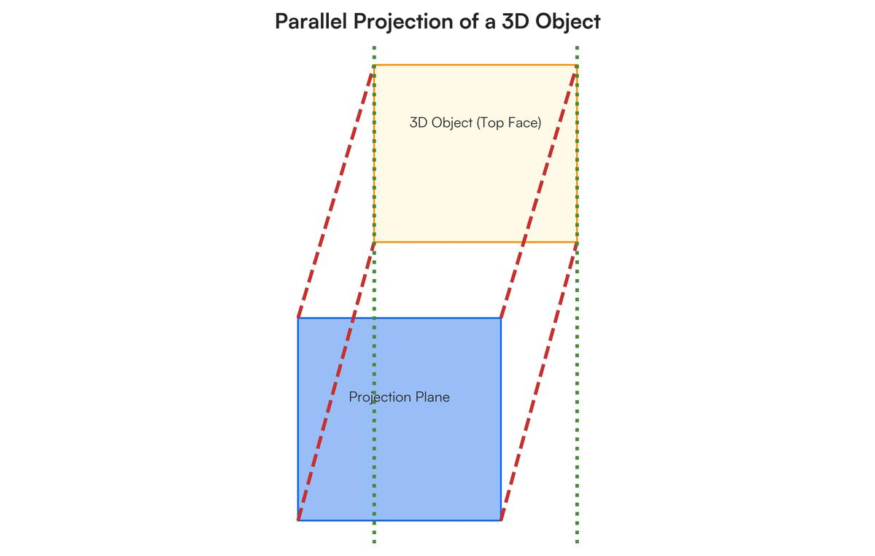
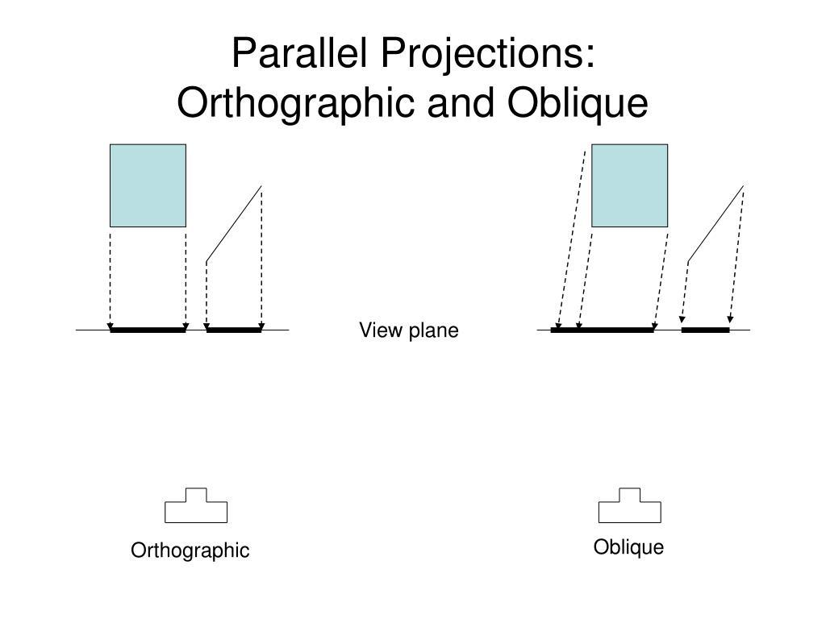
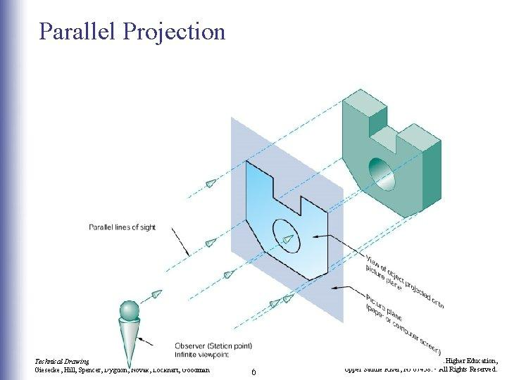

Definition
# Source: AI Source: Provided by: [Data Path: Persons Table -> ID Column: 1, Name_En Column: Motasem Essam] -> From: [ChatGPT] on [7/25/2026]
Parallel projection is a type of geometric projection in which all projection lines are parallel to one another.
An object is projected onto a target line or plane along a fixed projection direction.
If $P$ is a point and $P^{'}$ is its projection onto plane $Π$, then:
$$P^{'}=P+td$$
where:
- $P$ = original point
- $P^{'}$ = projected point
- $d$ = projection direction
- $t$ = scalar determining where the projection line meets the target
The defining property is:
$$\boxed{\text{All projection lines are parallel}}$$

Purpose
# Source: AI Source: Provided by: [Data Path: Persons Table -> ID Column: 1, Name_En Column: Motasem Essam] -> From: [ChatGPT] on [7/25/2026]
Parallel projection is used to:
- Represent 3D objects on 2D planes.
- Study geometric relationships.
- Create technical drawings.
- Visualize engineering objects.
- Perform mathematical projections.
- Preserve parallelism.
- Simplify 3D geometry into 2D representations.

Basic Configuration
# Source: AI Source: Provided by: [Data Path: Persons Table -> ID Column: 1, Name_En Column: Motasem Essam] -> From: [ChatGPT] on [7/25/2026]
Consider a 3D object above a projection plane $Π$.
Each point of the object is connected to the projection plane by a line in the same direction.

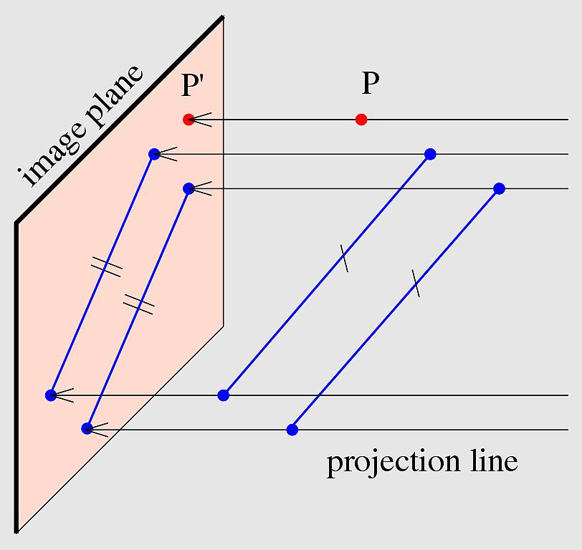
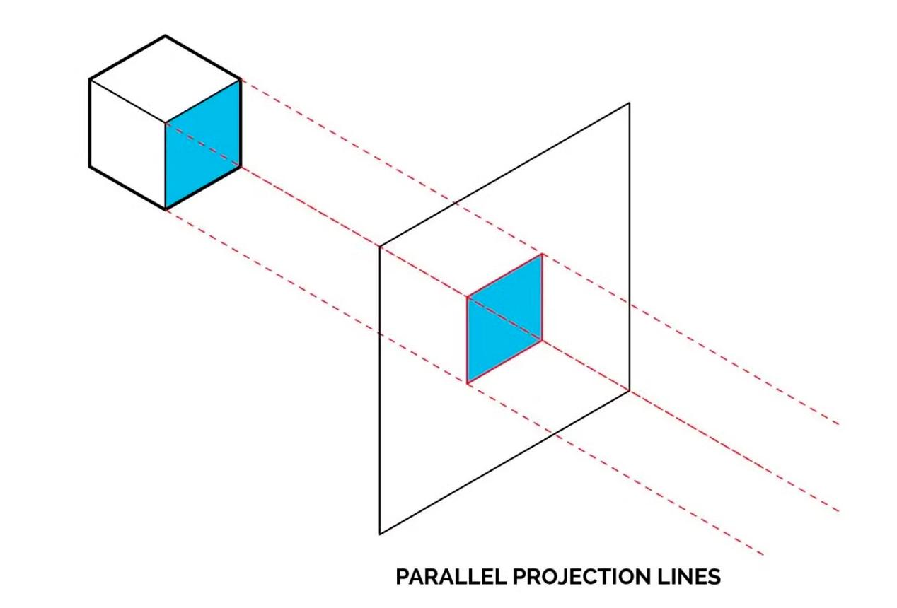
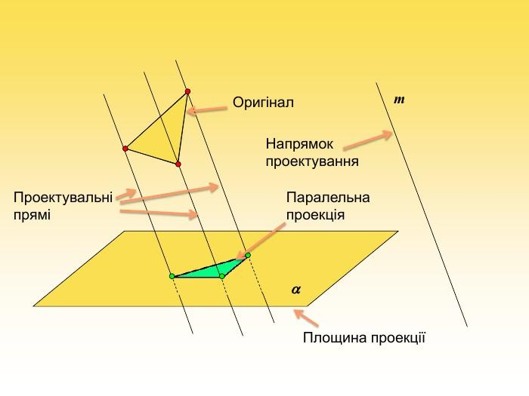
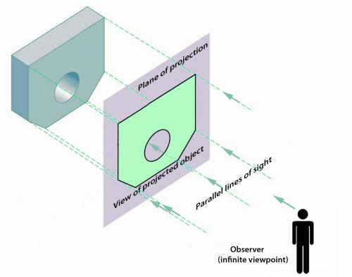

For points $A,B,C$:
$A→A^{'}$ $B→B^{'}$ $C→C^{'}$
The projection lines:
$$AA^{'}, BB^{'}, CC^{'}$$
are parallel.
Therefore:
$$\boxed{AA^{'}∥BB^{'}∥CC^{'}}$$

Fundamental Elements
# Source: AI Source: Provided by: [Data Path: Persons Table -> ID Column: 1, Name_En Column: Motasem Essam] -> From: [ChatGPT] on [7/25/2026]
A parallel projection consists of:

1. Original Object
# Source: AI Source: Provided by: [Data Path: Persons Table -> ID Column: 1, Name_En Column: Motasem Essam] -> From: [ChatGPT] on [7/25/2026]
The object being projected.
It may be:
- a point,
- line,
- segment,
- polygon,
- surface,
- 3D solid.

2. Projection Direction
# Source: AI Source: Provided by: [Data Path: Persons Table -> ID Column: 1, Name_En Column: Motasem Essam] -> From: [ChatGPT] on [7/25/2026]
A fixed direction represented by:
$$d$$
Every projection line follows this direction.

3. Projection Plane
# Source: AI Source: Provided by: [Data Path: Persons Table -> ID Column: 1, Name_En Column: Motasem Essam] -> From: [ChatGPT] on [7/25/2026]
The plane onto which the object is projected:
$$Π$$

4. Projected Object
# Source: AI Source: Provided by: [Data Path: Persons Table -> ID Column: 1, Name_En Column: Motasem Essam] -> From: [ChatGPT] on [7/25/2026]
The resulting image of the original object on $Π$.

Types of Parallel Projection
# Source: AI Source: Provided by: [Data Path: Persons Table -> ID Column: 1, Name_En Column: Motasem Essam] -> From: [ChatGPT] on [7/25/2026]
There are two major types:
$\boxed{\text{Parallel Projection}→\left\{\begin{matrix}\text{Orthogonal Projection} \\ \text{Oblique Projection}\end{matrix}\right.}$
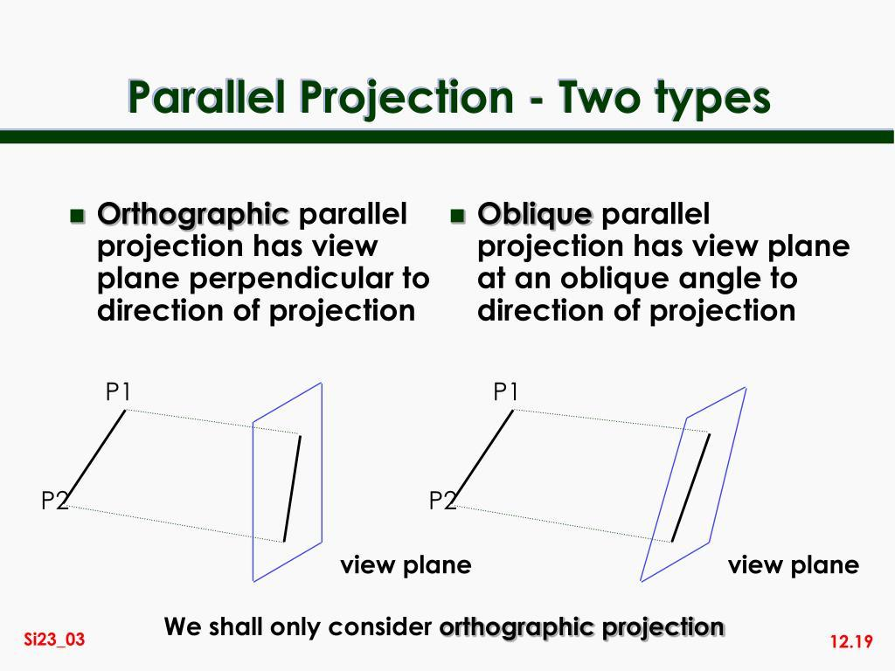
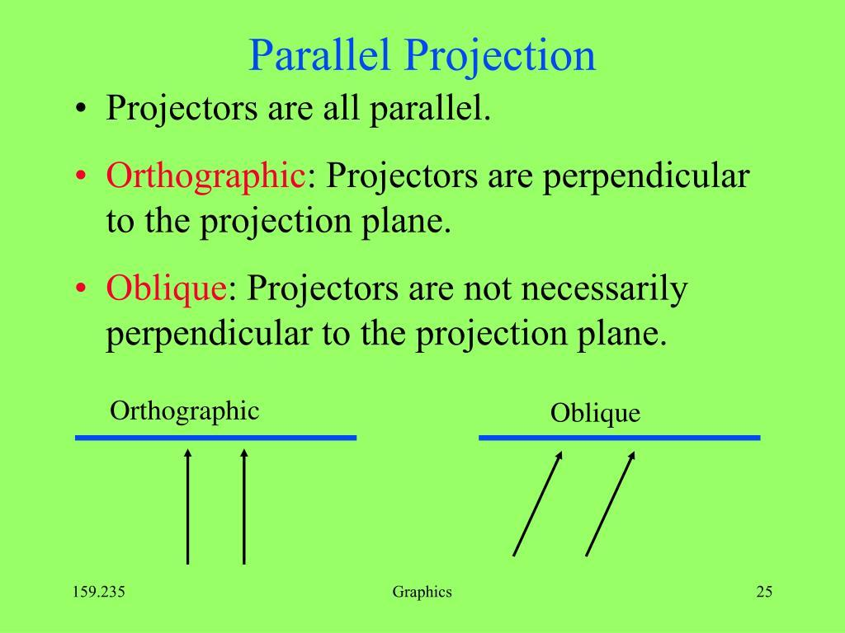

1. Orthogonal Projection
# Source: AI Source: Provided by: [Data Path: Persons Table -> ID Column: 1, Name_En Column: Motasem Essam] -> From: [ChatGPT] on [7/25/2026]
In orthogonal projection, the projection direction is perpendicular to the target plane.
$$\boxed{d⟂Π}$$
Therefore:
$$PP^{'}⟂Π$$
This is also called orthographic projection in many technical-drawing contexts.
Example:
A point $P$ is projected directly downward onto a horizontal plane.

2. Oblique Projection
# Source: AI Source: Provided by: [Data Path: Persons Table -> ID Column: 1, Name_En Column: Motasem Essam] -> From: [ChatGPT] on [7/25/2026]
In oblique projection, the projection direction is inclined to the target plane.
$$\boxed{d⟂̸Π}$$
The projection lines remain parallel, but they are not perpendicular to the plane.
Therefore:
$$\boxed{\text{Oblique projection is also a parallel projection}}$$

Parallel Projection of a Point
# Source: AI Source: Provided by: [Data Path: Persons Table -> ID Column: 1, Name_En Column: Motasem Essam] -> From: [ChatGPT] on [7/25/2026]
For a point:
$$P=(x,y,z)$$
the projection follows:
$$P^{'}=P+td$$
where $t$ is chosen so that:
$$P^{'}∈Π$$
Thus:
$$\boxed{P^{'}=P+td}$$
is the general mathematical representation.

Parallel Projection of a Line
# Source: AI Source: Provided by: [Data Path: Persons Table -> ID Column: 1, Name_En Column: Motasem Essam] -> From: [ChatGPT] on [7/25/2026]
Suppose line $L$ has points $A$ and $B$.
Project:
$$A→A^{'}$$
and:
$$B→B^{'}$$
Then the projected line is:
$$\boxed{A^{'}B^{'}}$$
If the original line is parallel to the projection direction, its projection can collapse into a single point.
This is an important special case.

Parallel Projection of a Line Segment
# Source: AI Source: Provided by: [Data Path: Persons Table -> ID Column: 1, Name_En Column: Motasem Essam] -> From: [ChatGPT] on [7/25/2026]
Suppose segment $AB$ is projected onto a plane.
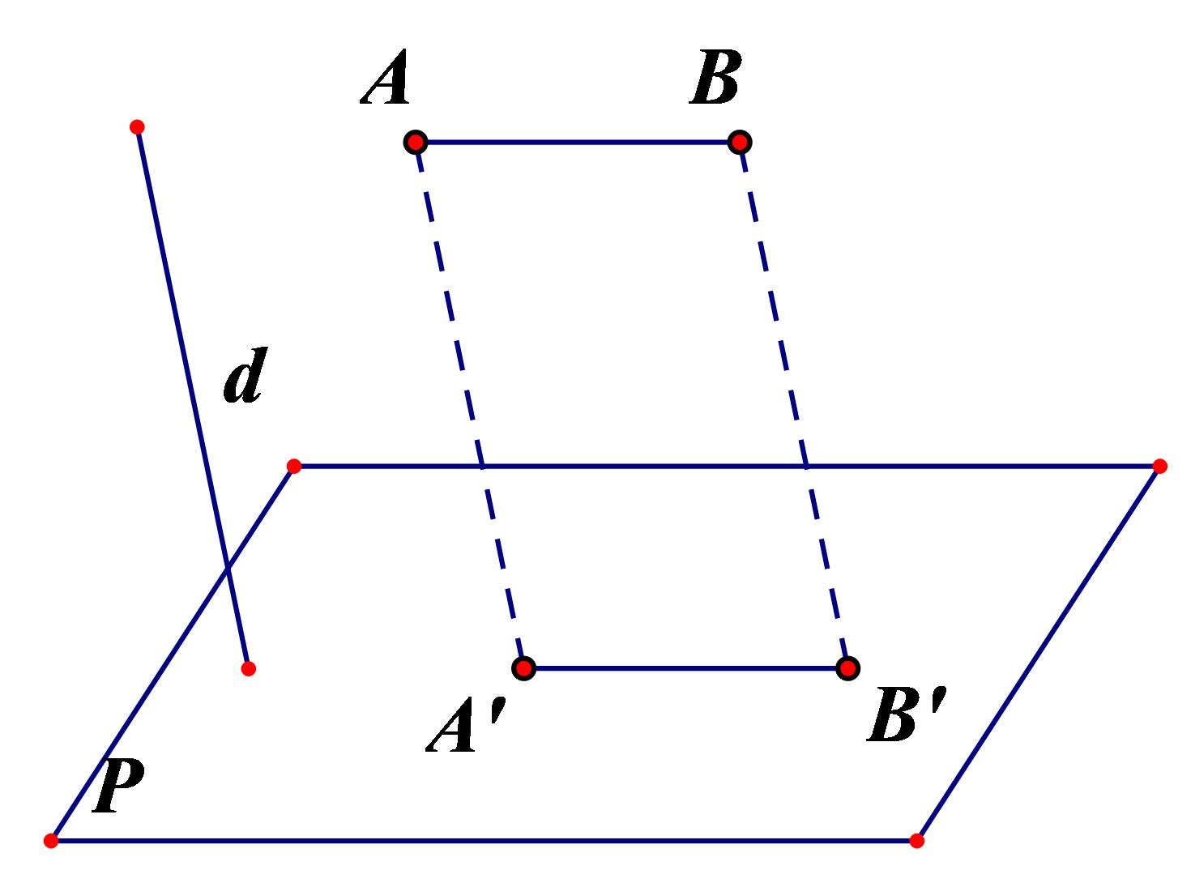
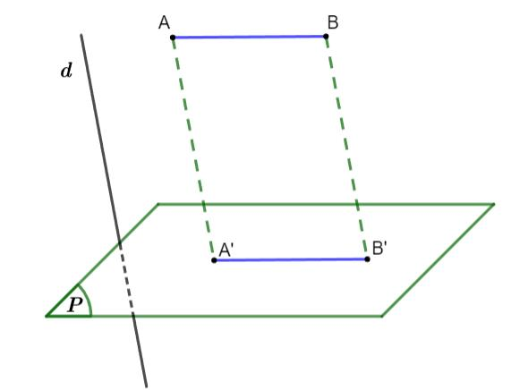
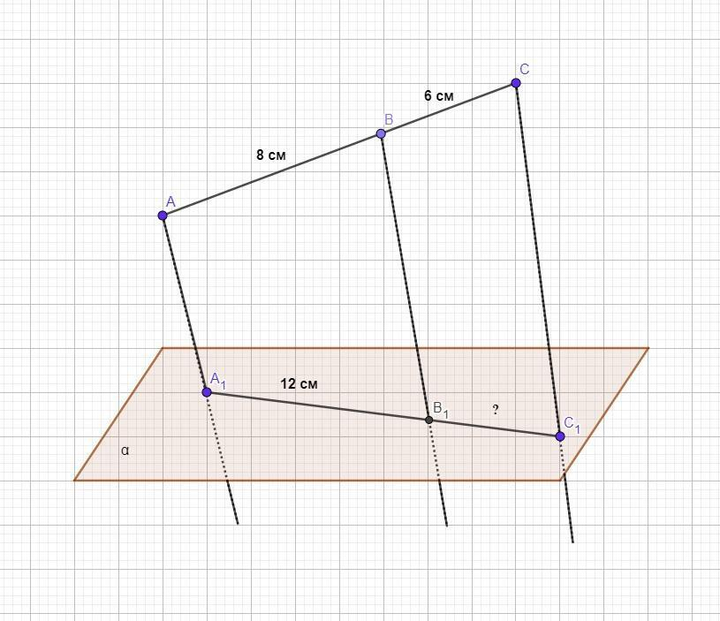
The endpoints become:
$A→A^{'}$ $B→B^{'}$
and the projected segment is:
$$\boxed{A^{'}B^{'}}$$
Because the projection is parallel, the projection lines satisfy:
$$AA^{'}∥BB^{'}$$

Parallel Projection of a 3D Object
# Source: AI Source: Provided by: [Data Path: Persons Table -> ID Column: 1, Name_En Column: Motasem Essam] -> From: [ChatGPT] on [7/25/2026]
Parallel projection is commonly used to display a three-dimensional object on a two-dimensional plane.
For example, a cube can be projected onto a plane.
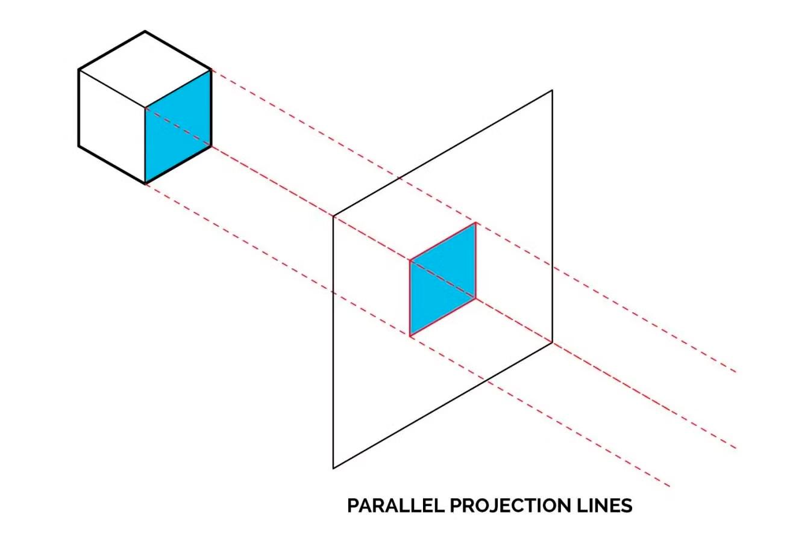
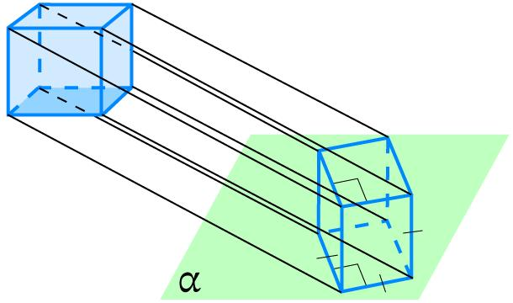
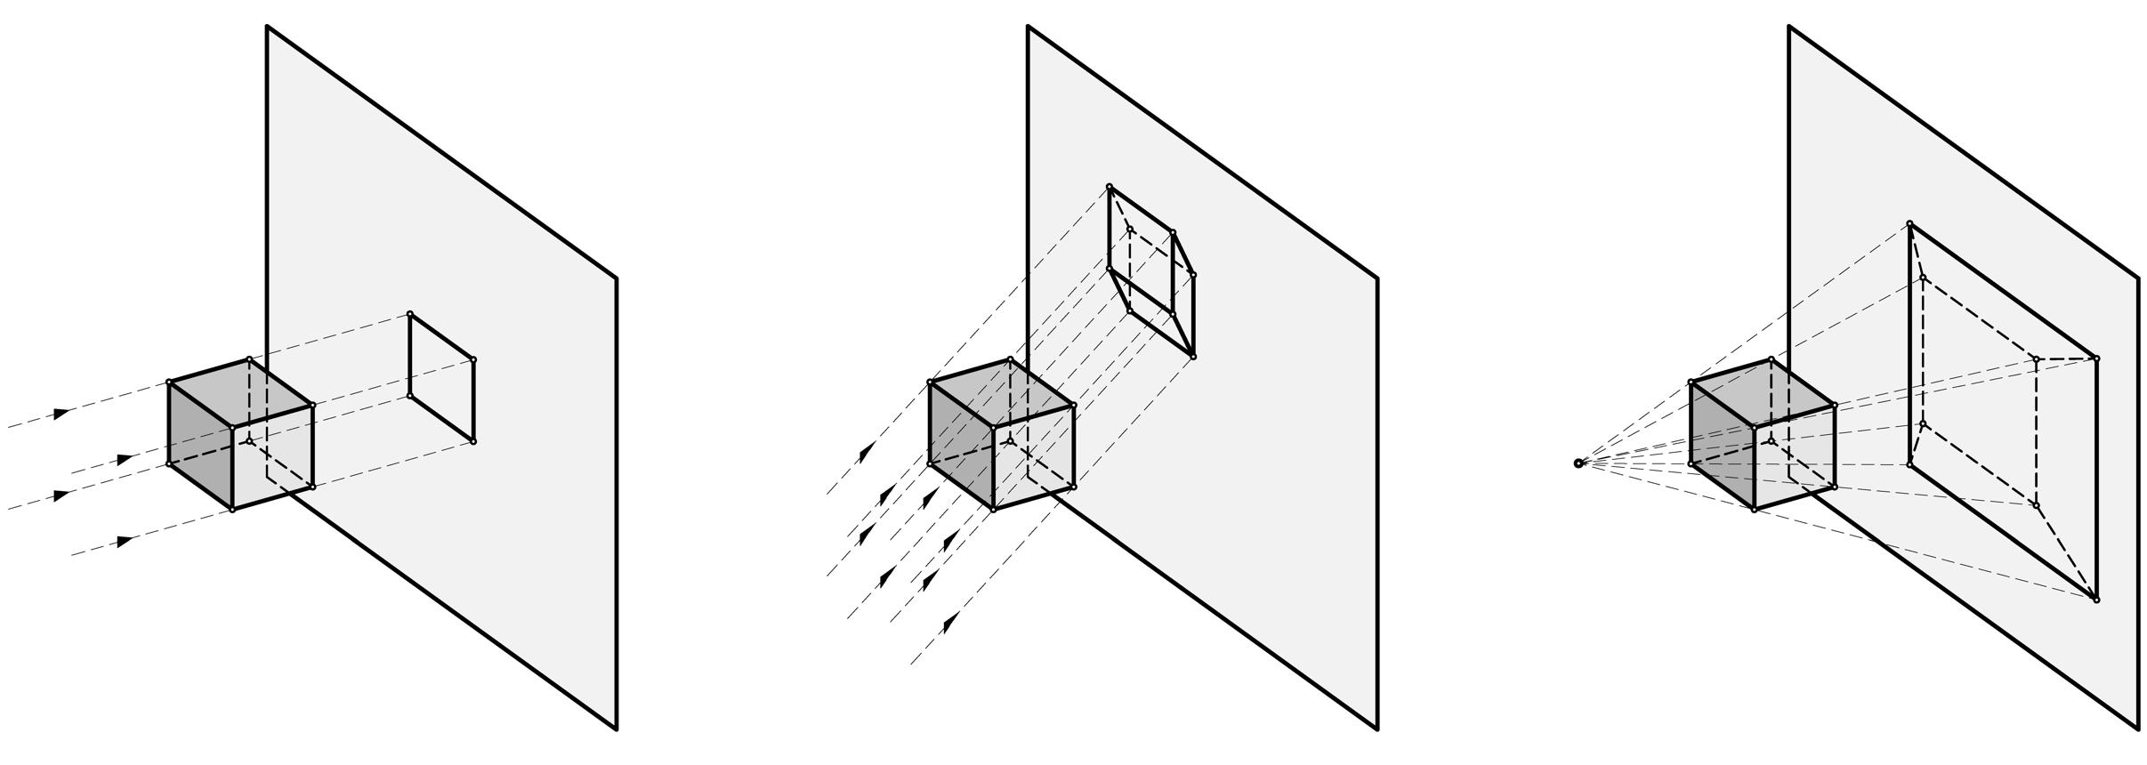
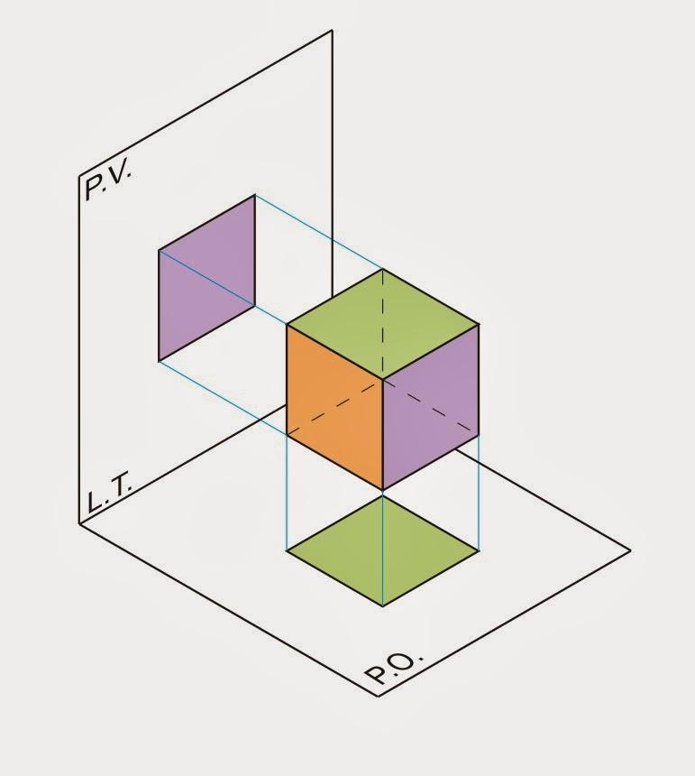
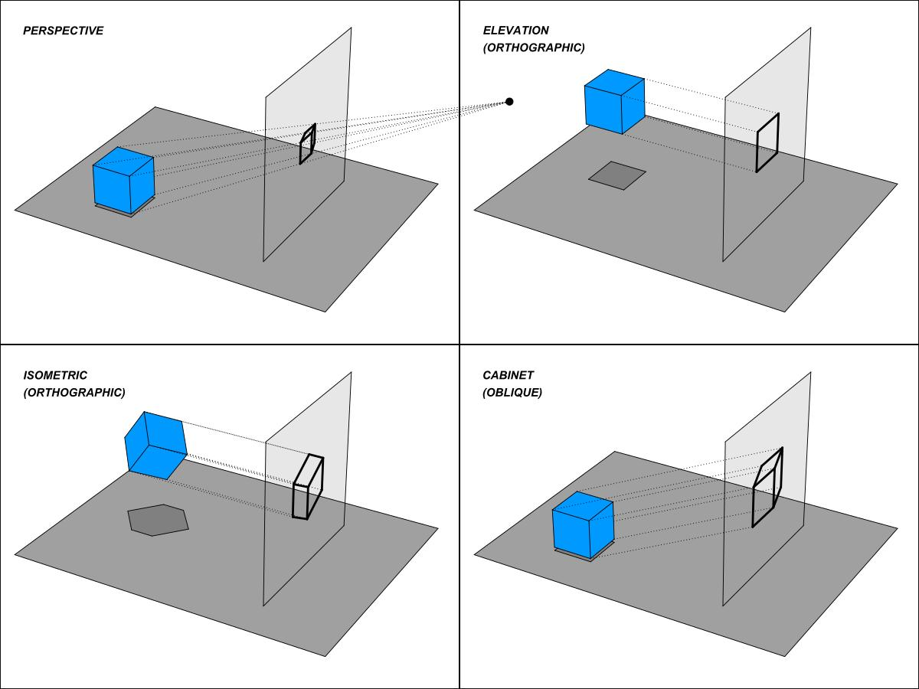
Every vertex is projected along the same direction.
The resulting image can show:
- faces,
- edges,
- vertices,
- depth relationships.

Mathematical Properties
# Source: AI Source: Provided by: [Data Path: Persons Table -> ID Column: 1, Name_En Column: Motasem Essam] -> From: [ChatGPT] on [7/25/2026]
Parallel projection has several important geometric properties.

1. Parallelism is Preserved
# Source: AI Source: Provided by: [Data Path: Persons Table -> ID Column: 1, Name_En Column: Motasem Essam] -> From: [ChatGPT] on [7/25/2026]
If two lines are parallel in the original object, their projected images generally remain parallel, provided they do not collapse into a point.
$$AB∥CD$$
leads to:
$$\boxed{A^{'}B^{'}∥C^{'}D^{'}}$$
This is one of the major differences between parallel and perspective projection.

2. Projection Lines Are Parallel
# Source: AI Source: Provided by: [Data Path: Persons Table -> ID Column: 1, Name_En Column: Motasem Essam] -> From: [ChatGPT] on [7/25/2026]
For points $A,B,C$:
$$\boxed{AA^{'}∥BB^{'}∥CC^{'}}$$
This is the defining property.

3. No Vanishing Point
# Source: AI Source: Provided by: [Data Path: Persons Table -> ID Column: 1, Name_En Column: Motasem Essam] -> From: [ChatGPT] on [7/25/2026]
Parallel projection does not require vanishing points.
Parallel lines remain parallel rather than converging toward a point.

4. Lengths Are Not Generally Preserved
# Source: AI Source: Provided by: [Data Path: Persons Table -> ID Column: 1, Name_En Column: Motasem Essam] -> From: [ChatGPT] on [7/25/2026]
In general:
$$\boxed{A^{'}B^{'}≠AB}$$
unless the geometry and projection direction produce a special case.

5. Angles Are Not Generally Preserved
# Source: AI Source: Provided by: [Data Path: Persons Table -> ID Column: 1, Name_En Column: Motasem Essam] -> From: [ChatGPT] on [7/25/2026]
Generally:
$$\boxed{∠A^{'}B^{'}C^{'}≠∠ABC}$$
Therefore, parallel projection is not normally an angle-preserving transformation.

Projection of Length
# Source: AI Source: Provided by: [Data Path: Persons Table -> ID Column: 1, Name_En Column: Motasem Essam] -> From: [ChatGPT] on [7/25/2026]
For an orthogonal projection of a segment of length $L$ onto a line making angle $θ$ with the segment:
$$\boxed{L_{\text{projection}}=L|cosθ|}$$
This connects parallel projection with trigonometry.
For oblique projection, the exact scale of the projected length depends on the projection direction and target geometry.

Coordinate Representation
# Source: AI Source: Provided by: [Data Path: Persons Table -> ID Column: 1, Name_En Column: Motasem Essam] -> From: [ChatGPT] on [7/25/2026]
Suppose the projection plane is:
$$z=0$$
and the projection direction is:
$$d=(d_{x},d_{y},d_{z})$$
For:
$$P=(x,y,z)$$
the projection is:
$$P^{'}=P+td$$
Since $P^{'}$ must satisfy $z=0$:
$$z+td_{z}=0$$
Therefore:
$$t=-\frac{z}{d_{z}}$$
and:
$$\boxed{P^{'}=\left(x-\frac{zd_{x}}{d_{z}},y-\frac{zd_{y}}{d_{z}},0\right)}$$
provided:
$$d_{z}≠0$$

Parallel Projection and Trigonometry
# Source: AI Source: Provided by: [Data Path: Persons Table -> ID Column: 1, Name_En Column: Motasem Essam] -> From: [ChatGPT] on [7/25/2026]
Projection can be understood through the components of a vector.
If vector $a$ has magnitude $L$ and makes angle $θ$ with the projection direction, its component along that direction is:
$$\boxed{Lcosθ}$$
The perpendicular component is:
$$\boxed{Lsinθ}$$
Thus:
$$L^{2}=(Lcosθ)^{2}+(Lsinθ)^{2}$$
which gives:
$$\sin^{2}θ+\cos^{2}θ=1$$
So parallel projection has a direct connection to trigonometry and vector projection.

Parallel Projection and Vector Projection
# Source: AI Source: Provided by: [Data Path: Persons Table -> ID Column: 1, Name_En Column: Motasem Essam] -> From: [ChatGPT] on [7/25/2026]
Vector projection asks:
How much of vector $a$ lies in the direction of vector $b$?
The vector projection is:
$$\boxed{{proj}_{b}(a)=\frac{a⋅b}{∥b∥^{2}}b}$$
This is closely related to the geometric idea of projecting an object along a particular direction.

Parallel Projection vs. Perspective Projection
# Source: AI Source: Provided by: [Data Path: Persons Table -> ID Column: 1, Name_En Column: Motasem Essam] -> From: [ChatGPT] on [7/25/2026]
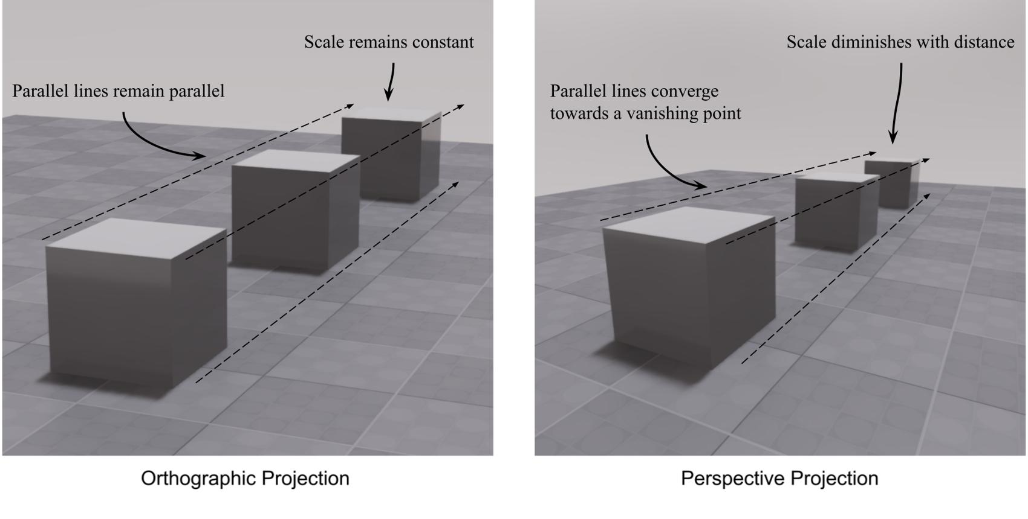
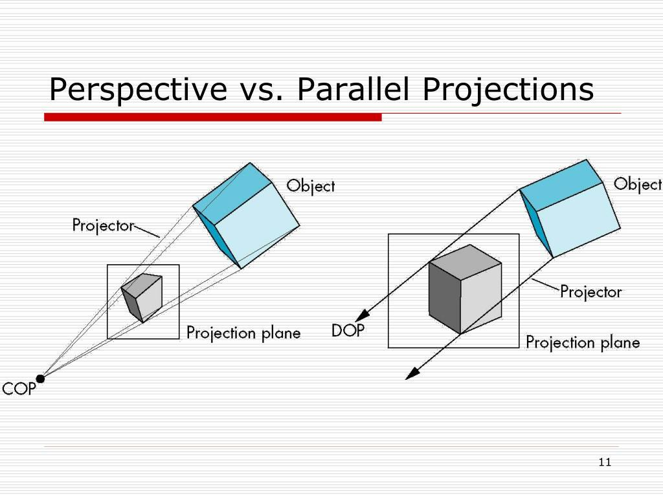
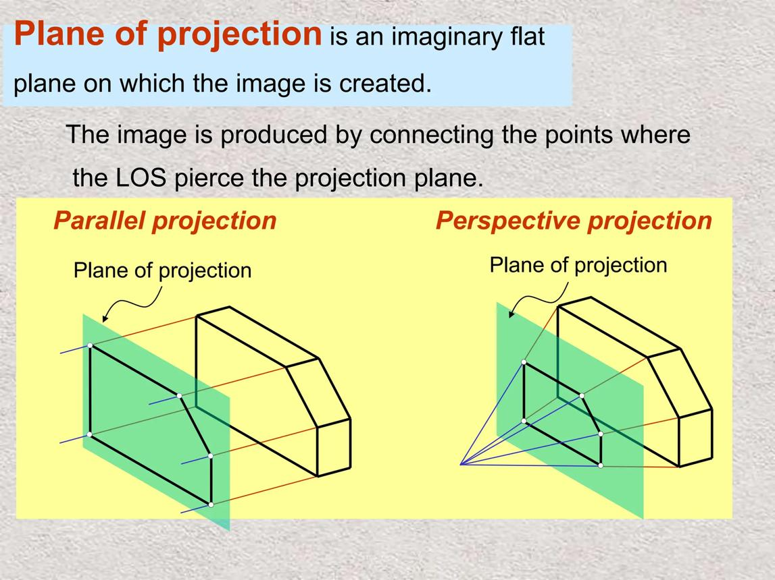
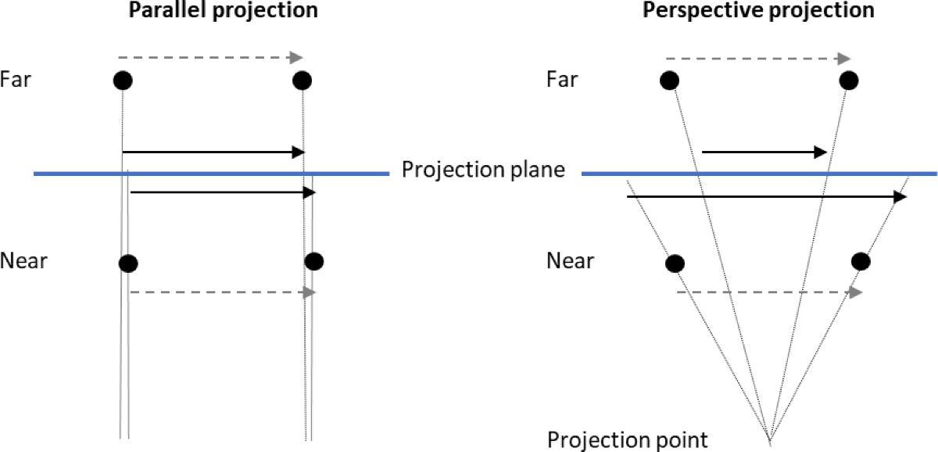
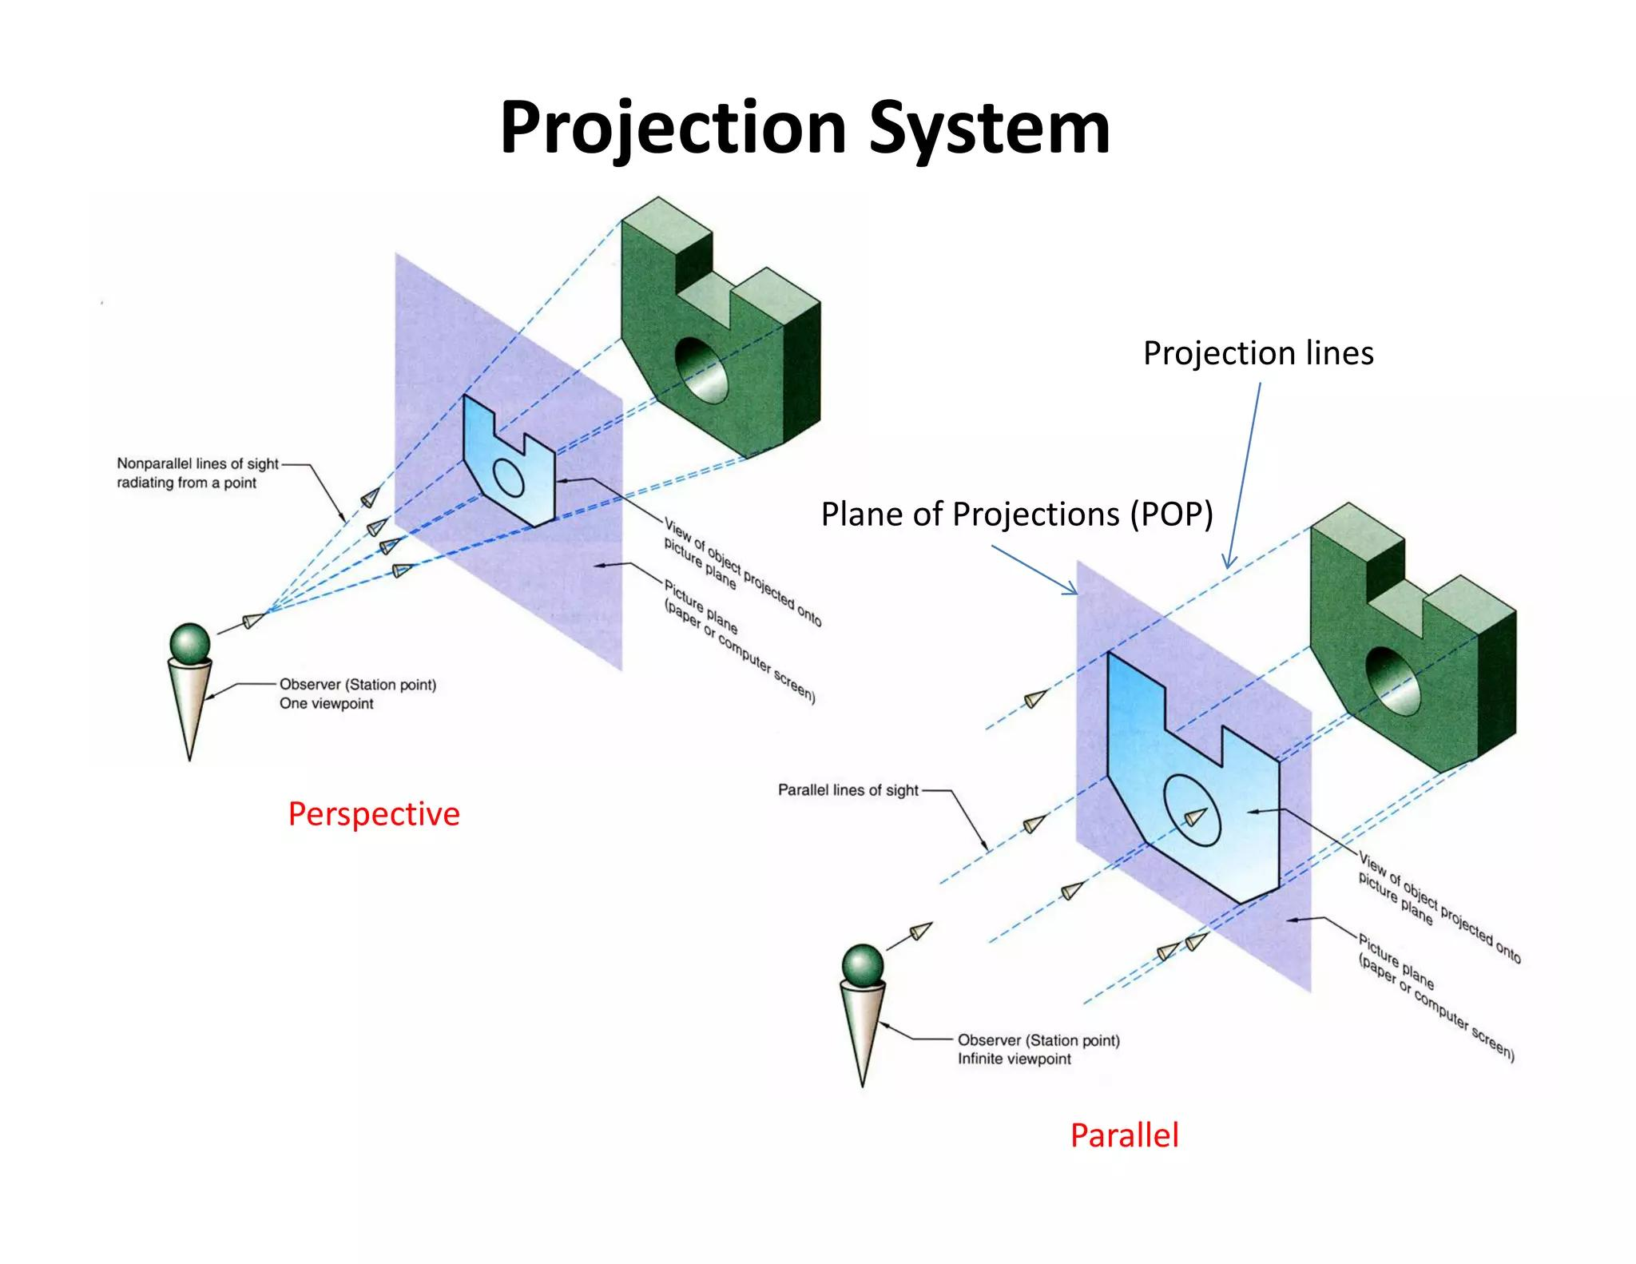
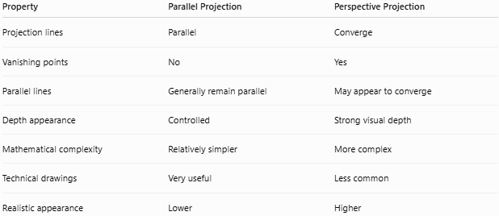
Property | Parallel Projection | Perspective Projection
Projection lines | Parallel | Converge
Vanishing points | No | Yes
Parallel lines | Generally remain parallel | May appear to converge
Depth appearance | Controlled | Strong visual depth
Mathematical complexity | Relatively simpler | More complex
Technical drawings | Very useful | Less common
Realistic appearance | Lower | Higher

Orthogonal vs. Oblique Parallel Projection
# Source: AI Source: Provided by: [Data Path: Persons Table -> ID Column: 1, Name_En Column: Motasem Essam] -> From: [ChatGPT] on [7/25/2026]
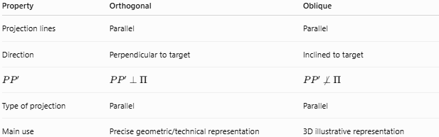
Property | Orthogonal | Oblique
Projection lines | Parallel | Parallel
Direction | Perpendicular to target | Inclined to target
$$PP^{'}$$ | $$PP^{'}⟂Π$$ | $$PP^{'}⟂̸Π$$
Type of projection | Parallel | Parallel
Main use | Precise geometric/technical representation | 3D illustrative representation
Therefore:
$$\boxed{\text{Orthogonal and Oblique are both types of Parallel Projection}}$$

Special Cases

Projection Direction Parallel to the Target Plane
# Source: AI Source: Provided by: [Data Path: Persons Table -> ID Column: 1, Name_En Column: Motasem Essam] -> From: [ChatGPT] on [7/25/2026]
If:
$$d∥Π$$
then projection lines may never intersect the plane.
Therefore, a proper projection onto that plane is not defined for those points using that direction.

Object Parallel to Projection Plane
# Source: AI Source: Provided by: [Data Path: Persons Table -> ID Column: 1, Name_En Column: Motasem Essam] -> From: [ChatGPT] on [7/25/2026]
If an object lies parallel to the projection plane, its projection can preserve its shape and scale under an appropriate parallel projection.

Segment Parallel to Projection Direction
# Source: AI Source: Provided by: [Data Path: Persons Table -> ID Column: 1, Name_En Column: Motasem Essam] -> From: [ChatGPT] on [7/25/2026]
If a segment is parallel to the projection direction, its endpoints may project to the same point:
$$\boxed{A^{'}=B^{'}}$$
Thus the segment collapses to a point.

Applications
# Source: AI Source: Provided by: [Data Path: Persons Table -> ID Column: 1, Name_En Column: Motasem Essam] -> From: [ChatGPT] on [7/25/2026]
Parallel projection is widely used in:
- Engineering drawing
- Architecture
- Mechanical design
- Computer graphics
- CAD
- Technical illustration
- Geometry
- 3D modeling
- Scientific visualization
- Educational diagrams

Advantages
# Source: AI Source: Provided by: [Data Path: Persons Table -> ID Column: 1, Name_En Column: Motasem Essam] -> From: [ChatGPT] on [7/25/2026]
- Simple geometric construction.
- Projection lines remain parallel.
- Preserves parallel relationships.
- No vanishing-point calculations are required.
- Useful for technical drawings.
- Can represent 3D objects clearly.
- Easier to analyze mathematically than perspective projection.

Limitations
# Source: AI Source: Provided by: [Data Path: Persons Table -> ID Column: 1, Name_En Column: Motasem Essam] -> From: [ChatGPT] on [7/25/2026]
- Does not produce realistic perspective.
- Objects do not naturally appear smaller with distance.
- Lengths are not generally preserved.
- Angles are not generally preserved.
- Depth can appear distorted.
- Some objects or segments can collapse into points.

Comparison with Related Concepts
# Source: AI Source: Provided by: [Data Path: Persons Table -> ID Column: 1, Name_En Column: Motasem Essam] -> From: [ChatGPT] on [7/25/2026]
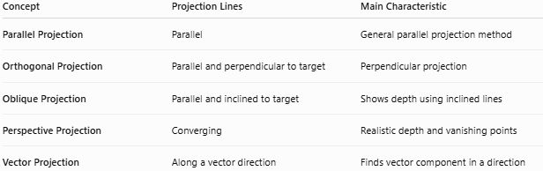
Concept | Projection Lines | Main Characteristic
Parallel Projection | Parallel | General parallel projection method
Orthogonal Projection | Parallel and perpendicular to target | Perpendicular projection
Oblique Projection | Parallel and inclined to target | Shows depth using inclined lines
Perspective Projection | Converging | Realistic depth and vanishing points
Vector Projection | Along a vector direction | Finds vector component in a direction

Hierarchy of Geometric Projection
# Source: AI Source: Provided by: [Data Path: Persons Table -> ID Column: 1, Name_En Column: Motasem Essam] -> From: [ChatGPT] on [7/25/2026]
A useful classification for your geometry knowledge base is:
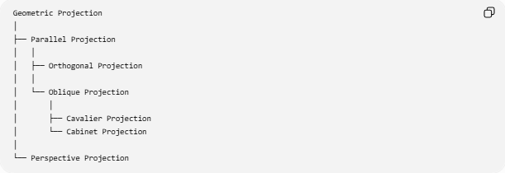
Geometric Projection
│
├── Parallel Projection
│ │
│ ├── Orthogonal Projection
│ │
│ └── Oblique Projection
│ │
│ ├── Cavalier Projection
│ └── Cabinet Projection
│
└── Perspective Projection
This makes the relationship between the projection topics clear:
$$\boxed{\text{Parallel Projection}=\text{Orthogonal Projection}+\text{Oblique Projection}}$$

Key Points
# Source: AI Source: Provided by: [Data Path: Persons Table -> ID Column: 1, Name_En Column: Motasem Essam] -> From: [ChatGPT] on [7/25/2026]
- Parallel projection projects an object using projection lines that are all parallel.
- Its defining property is:
$$\boxed{AA^{'}∥BB^{'}∥CC^{'}}$$
- It has two major forms:
  - Orthogonal projection
  - Oblique projection
- Orthogonal projection uses a direction perpendicular to the target.
- Oblique projection uses an inclined direction.
- Parallel projection has no vanishing points.
- Parallelism is generally preserved.
- Lengths and angles are not generally preserved.
- A segment parallel to the projection direction can collapse to a point.
- Parallel projection is widely used in geometry, engineering, CAD, and technical visualization.

Conclusion
# Source: AI Source: Provided by: [Data Path: Persons Table -> ID Column: 1, Name_En Column: Motasem Essam] -> From: [ChatGPT] on [7/25/2026]
Parallel Projection is the general class of geometric projection in which all projection lines are parallel.
Its fundamental structure is:
$$\boxed{\text{Parallel Projection}→\left\{\begin{matrix}\text{Orthogonal Projection} \\ \text{Oblique Projection}\end{matrix}\right.}$$
The key distinction is therefore:
$$\boxed{\text{Parallel projection: projection lines remain parallel}}$$
while perspective projection uses converging projection lines.

